Autograder

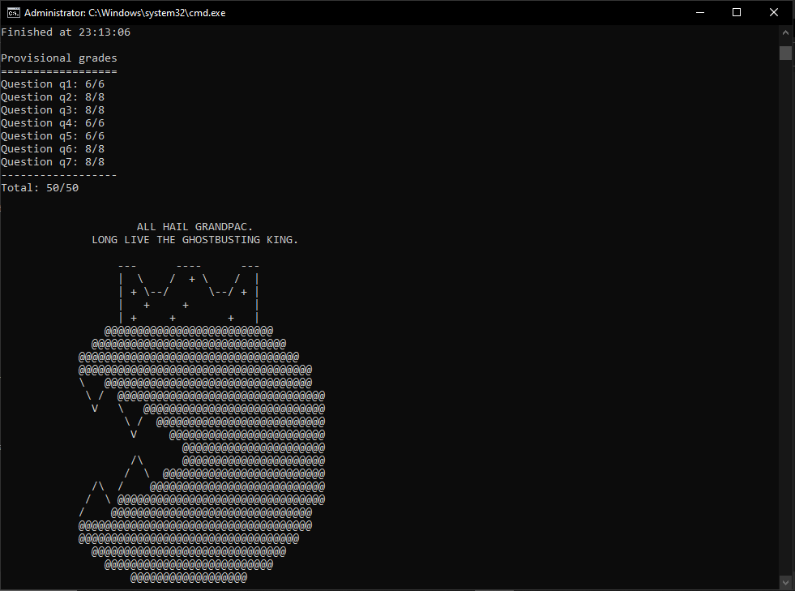

Question 1 (6 points): Observation Probability –

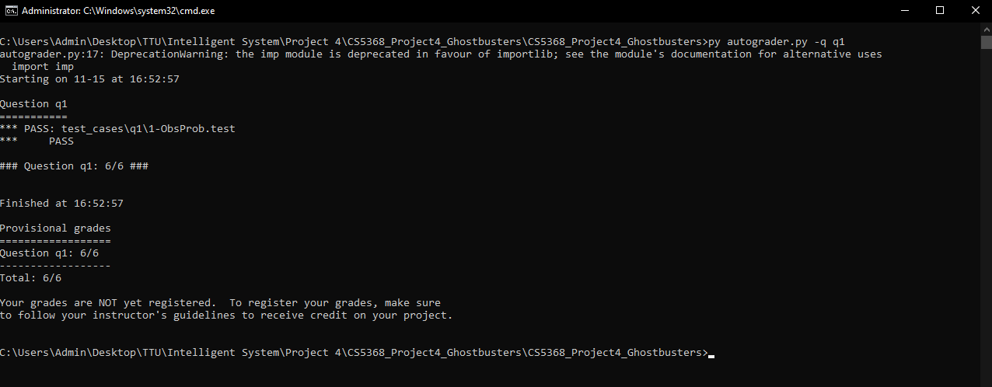

Question 2 (8 points): Exact Inference Observation –

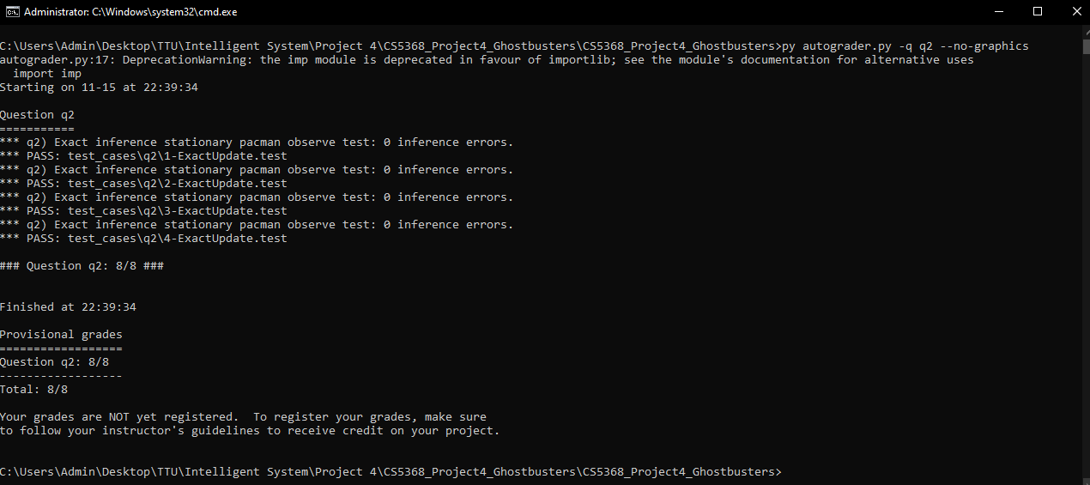

Question 3 (8 points): Exact Inference with Time Elapse –

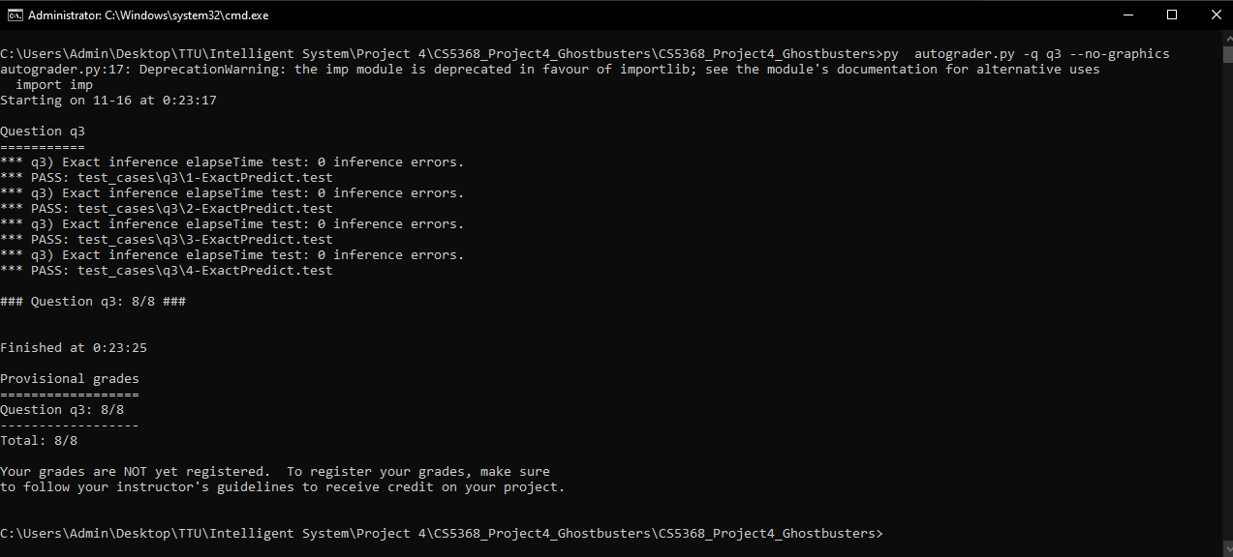

Question 4 (6 points): Exact Inference Full Test –

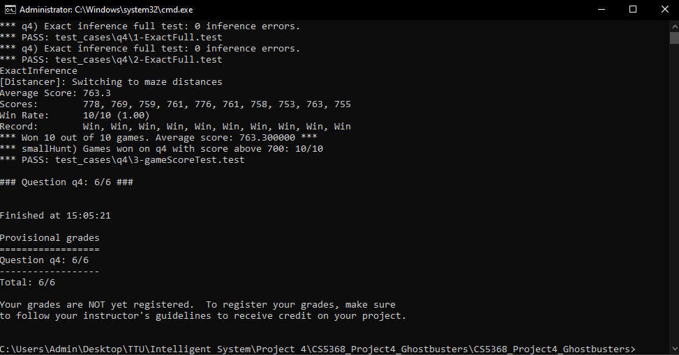

Question 5 (6 points): Approximate Inference Initialization and Beliefs –

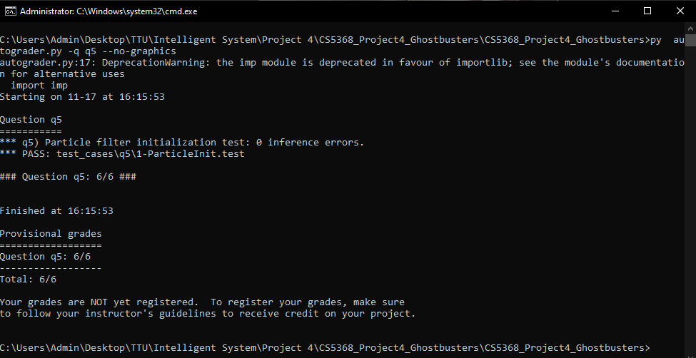

Question 6 (8 points): Approximate Inference Observation –

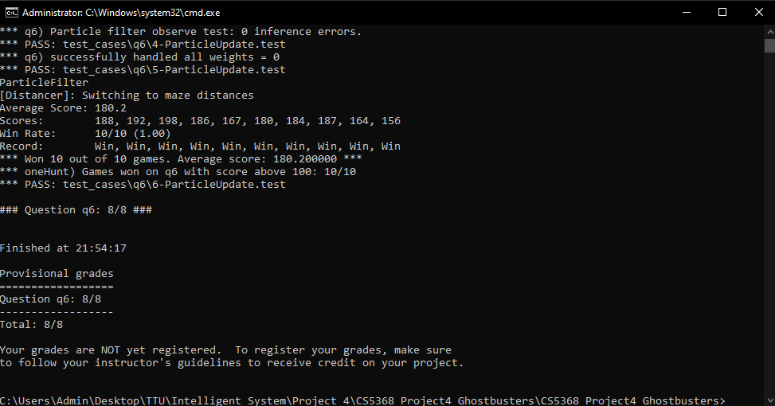

Question 7 (8 points): Approximate Inference with Time Elapse

